EPAG Round Three Factsheet for Recruitment

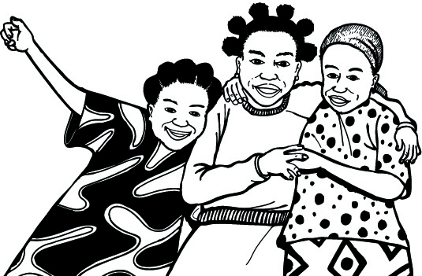
Economic Empowerment of Adolescent Girls & Young Women (EPAG) This factsheet tells selected participants more about the project:

What is EPAG?
“EPAG” stands for “economic empowerment of adolescent girls & young women.” The Ministry of Gender & Development (MoGD) is coordinating the project. In Buchanan city, MoGD is working with (three) NGOs: LEED, Educare, and NAEAL. This is the list of selected girls for the business development skills that we told you was coming up this week.

What is business development skill training?
Business development skills training teach you how to have a successful small business. It covers business skills like how to make a business plan, manage a budget, and do record-keeping. In the business development skills training, girls will also be taught on how to improve their reading and writing skills.

What is a life skill?
Life skills teach you how to take care of your body, interact with people etc.

What is job skill training?
Job skills training teach you skills for a specific wage-earning job. Jobs skills training also teach basic business skills.

Why all girls who registered are not selected?
The registration/recruitment process was free and fair. The Government of Liberia encouraged every adolescent girl and young woman to take part. But at the end of the day, there were certain requirements people have to meet before they are selected. So, those who are selected are the ones who met the requirements.

Everybody benefits!
This project is for the whole community. We want to tell all the community people and girls thanks for participating in the recruitment exercise. When you lift up girls, you lift up Grand Bassa County, and you lift Liberia! The number of spaces is limited. Please support the girls that are selected!

When is EPAG? How long is it?
There will be one round of training that will start on October 7, 2013. During this round of training, girls will undergo training for four-months followed by five-months of “mentoring, support, and placement.”

Does the EPAG project give money, loans, or toolkits?
No. The benefit of the EPAG project is high-quality skills training. The EPAG project will help girls to increase their business success, find & keep a job, stand on their own feet, get their own money, and build their confidence.

What happens next? Baseline assessment
In October 2013 there will be what’s called a “baseline” survey. This means that some of the selected girls will be visited by the EPAG survey firm team to collect information about the girl. No one will have to answer any question they do not want to. All information collected will be “confidential” or secret. Please tell your boyfriends, husbands, parents, and other family members about this opportunity.

What are the EPAG rules?
- A girl’s acceptance into the program is Non-transferable to any other person.
- If selected, a girl may NOT transfer to any other training site.
- If selected, the girl will be required to start training on October 7, 2013. Girls who do not show up within the first week of training will be immediately replaced by girls who are on standby.
- The girl IS NOT GUARANTEED employment or a loan upon completion of the program. Girls will receive a small stipend for transportation while attending the training.
- The project WILL help the girl make a better business & improve her life!
- The girl must attend training classes regularly or she will be asked to leave the program.
- Once a girl drops out of the program, she will not be allowed to rejoin at a future date.

